Project Proposal Template
Agentic AI Applications Course

Team Number:
Team Member Name (s): Shruthi D
Proposed Project Title: Real-Time Acceleration for Medical Image Processing with Agents

1. Problem Statement & Use Case: Your problem statement should answer the following questions clearly:
Modern medical imaging systems such as portable ultrasound devices process large volumes of sensor data in real time. While AI models can classify abnormalities (e.g., benign vs malignant), current systems stop at prediction. They do not autonomously interpret uncertainty, stratify clinical risk, recommend specialists, or coordinate follow-up actions. This leads to delays in diagnosis, inconsistent triage decisions, and workflow inefficiencies—especially in rural and resource-limited settings.
Who is the target user / beneficiary?
- Primary care physicians
- Radiologists
- Rural healthcare workers
- Hospitals implementing AI-assisted triage
- Patients needing faster clinical decisions
What currently happens (manual process, existing tools, pain points)?
Currently, ultrasound devices reconstruct images and sometimes apply AI classification. However, clinicians manually interpret results, determine risk, refer patients, and schedule appointments. Pain points include lack of uncertainty monitoring, no automated triage logic, inconsistent specialist referral decisions, and manual coordination delays.
Why is this a good fit for an agentic AI solution?
This workflow requires multi-step reasoning, autonomous decision-making, reflection, planning, and tool usage (e.g., booking APIs). A simple LLM or static classifier cannot monitor prediction stability, escalate high-risk cases, or coordinate structured follow-up actions. Therefore, a multi-agent system is necessary to manage perception, reasoning, and action.

2. Justify that your application is Agentic
Core agentic capabilities essential for the app:
- Tool Use: Integration with hospital databases and scheduling APIs.
- Reflection/Self-correction: Monitoring CNN confidence across frames.
- Planning & Decomposition: Risk → Specialist → Booking → Explanation.
- Multi-agent coordination: Separate agents for risk, booking, explanation.
- Memory: Tracking patient case state and frame-level consistency.
What would fail with a single LLM call?
A single LLM call would provide static output without iterative validation. It cannot track frame consistency, perform structured escalation, integrate robustly with APIs, or manage stateful workflows.
Expected agentic behavior examples:
- If CNN confidence fluctuates across frames, the Uncertainty Agent requests additional frames.
- If malignancy probability exceeds threshold, Risk Agent escalates automatically.
- If booking API fails, Booking Agent retries or selects alternate hospital.
- Explanation Agent adapts messaging tone based on severity.

3. High-Level Solution Overview
Main Agents and Roles:
1. Uncertainty Monitoring Agent – Validates prediction stability.
2. Risk Stratification Agent – Converts probabilities to structured risk categories.
3. Specialist Recommendation Agent – Maps risk level to appropriate doctor.
4. Booking Agent – Uses API/database to schedule appointment.
5. Explanation Agent – Generates patient-friendly summary.
Key Agentic Patterns:
- Reflection loop for uncertainty handling.
- Plan-and-execute workflow design.
- Multi-agent orchestration via LangGraph.
- Tool usage (hospital API, scheduling system).
- Short-term memory for frame tracking + structured case state.
High-Level Flow:
Raw RF Signal → Beamforming → Image Enhancement → CNN Inference → Uncertainty Agent → Risk Agent → Specialist Agent → Booking Agent → Explanation Agent → Final Output

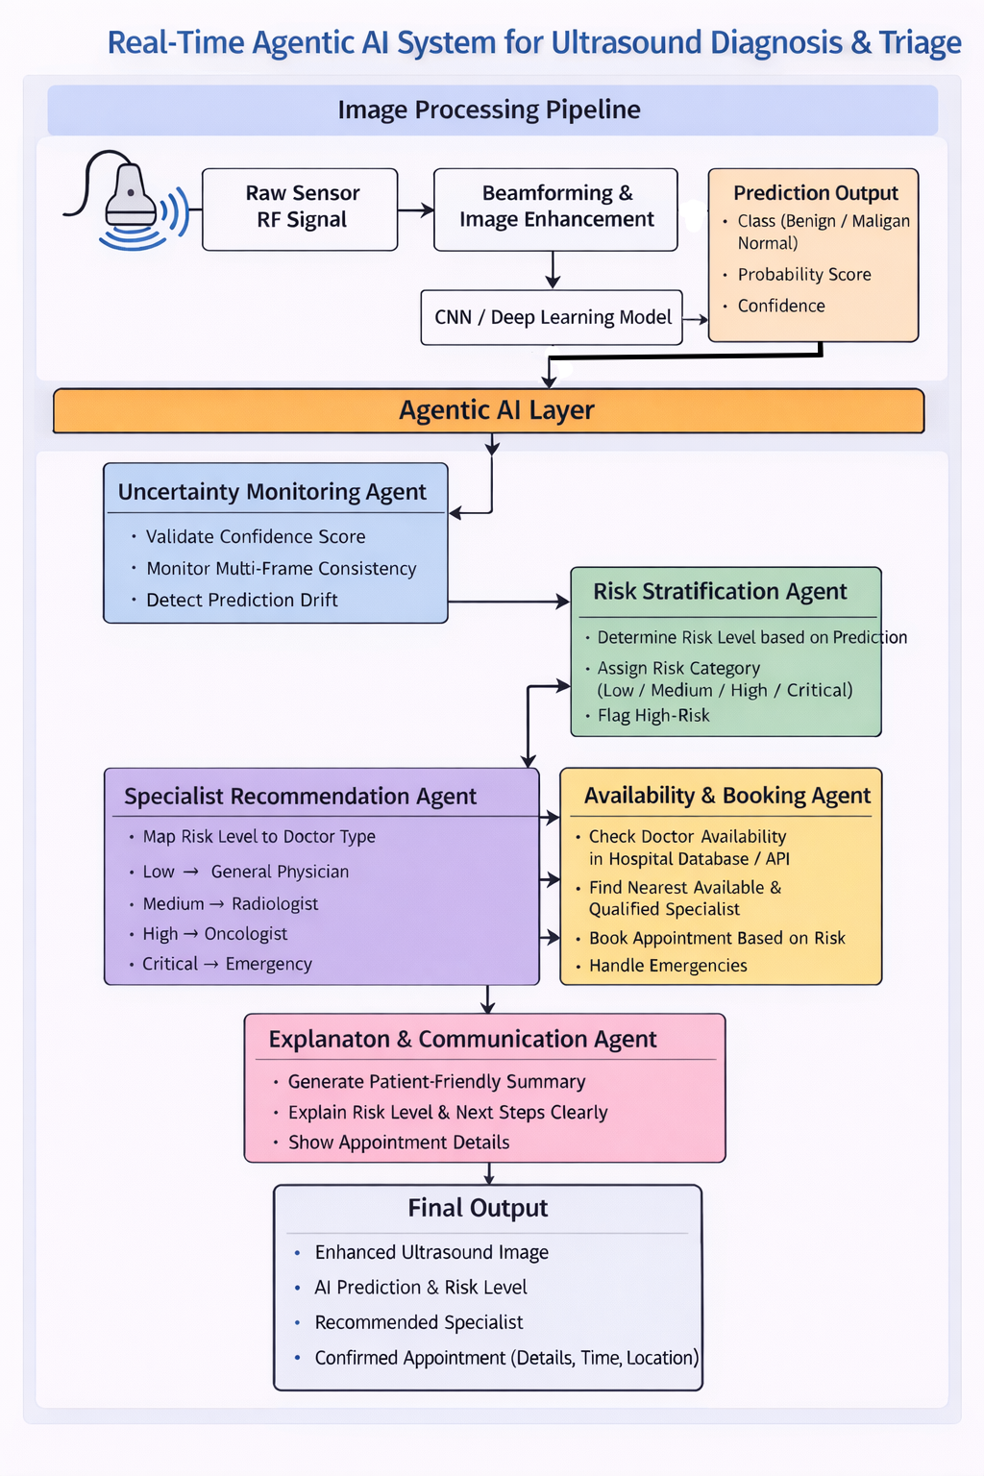

4. Proposed Technology Stack
LLM Provider: OpenAI GPT-4o
The LLM is not used for diagnosis, but for:
- Structured reasoning
- Explanation generation
- Workflow coordination
- Multi-agent communication
GPT-4o is selected because:
- Strong reasoning capabilities
- Reliable structured output (JSON mode)
- Low latency compared to larger models
- Cost-efficient for limited agent tasks
- Supports tool calling natively
Role in System
- Generates patient-friendly summary
- Formats specialist recommendation
- Assists in decision validation (not override)
- Coordinates booking workflow
🔹 Core Framework: LangGraph
System requires:
- State-based transitions
- Multi-agent coordination
- Controlled loops
- Error-handling nodes
- Deterministic flow control
LangGraph enables:
- Explicit graph structure
- Loop control
- Memory tracking
- Conditional branching
Example graph nodes:
CNN_Output → Uncertainty_Node → Risk_Node → Specialist_Node → Booking_Node → Explanation_Node
🔹 Tools Layer
1️⃣ Custom Doctor Booking API
Simulated REST API that:
- Accepts specialist type
- Returns available slots
- Confirms appointment
- Simulates failure cases
2️⃣ Hospital Database (JSON / SQL)
Stores:
- Doctor name
- Specialization
- Availability
- Location
- Emergency flag
🔹 Vector Database / Memory: Chroma
Used for:
- Storing previous patient case summaries
- Tracking prior risk decisions
- Maintaining state history
- Avoiding repetitive explanations
Memory Types:
- Short-term state memory (LangGraph state)
- Long-term case storage (Chroma vector DB)

🔹 Frontend: Streamlit Dashboard
Displays:
- Ultrasound image
- CNN prediction
- Risk level
- Recommended specialist
- Appointment details
Also shows:
- Agent decision logs
- Confidence tracking graph
- Latency metrics
Streamlit chosen because:
- Fast prototyping
- Easy integration with Python backend
- Lightweight deployment
🔹 Evaluation Tools
You will implement:
- Manual evaluation rubric
- Automated logging system
- Latency tracking
- Token usage tracking
- Tool call audit log
Each test case generates:
- JSON log file
- Agent decision trace
- Timing breakdown

🔹 Deployment Target
Two options:
1️⃣ Hugging Face Spaces
- Public demo
- Easy UI deployment
- GPU support (if needed)
2️⃣ Local Edge GPU Device
- Simulates real portable ultrasound environment
- Demonstrates real-time capability
This dual deployment shows practical applicability.
- Evaluation Tools: Manual rubric + custom metrics logging
- Deployment Target: Hugging Face Spaces or Local GPU Edge Device

5. Success Metrics & Evaluation Plan
Quantitative Metrics: Quantitative Metrics
1️⃣ Task Success Rate ≥ 85%
Definition:
Percentage of cases where:
- Risk level correctly assigned
- Specialist correctly mapped
- Booking completed successfully
2️⃣ Booking Accuracy ≥ 90%
Measures:
- Correct specialist selected
- Valid appointment time returned
- Urgency handled correctly
Important for workflow credibility.
3️⃣ Frame Consistency Detection Accuracy ≥ 90%
Uncertainty Agent must:
- Detect unstable predictions
- Identify drift
- Flag low-confidence frames
Measured using synthetic unstable prediction sets.
4️⃣ End-to-End Latency < 2 Seconds per Frame
Includes:
- Beamforming
- CNN inference
- Agent reasoning
- Tool call
Measured using:
- Timestamp logging
- Average across 20 test cases
Real-time constraint critical.
5️⃣ Tool-Call Success Rate ≥ 95%
Measures:
- Successful API execution
- Correct parameter passing
- Proper fallback when failure simulated
6️⃣ Cost per Task (Token Usage)
Track:
- Total tokens used per case
- LLM invocation frequency
- Cost optimization effectiveness
Goal:
Minimize unnecessary agent calls.
🔹 Qualitative Evaluation
1️⃣ Rubric-Based Evaluation
Medical/AI reviewers score outputs on:
- Clinical relevance
- Explanation clarity
- Logical coherence
- Completeness
- Safety wording
2️⃣ Mini User Study (5–10 Participants)
Participants evaluate:
- Ease of understanding
- Trustworthiness
- Clarity of explanation
- Perceived usefulness
3️⃣ ≥ 20 Structured Test Cases
Test cases include:
- Low-risk cases
- Medium-risk cases
- High-risk cases
- Uncertain predictions
- API failure simulation
- Drift scenarios
Ensures robustness.
🔹 Failure Modes & Measurement
Overconfidence Errors
Risk:
CNN gives high probability but incorrect label.
Mitigation:
Confidence calibration tracking.
Metric:
Expected Calibration Error (ECE).

Infinite Loops
Risk:
Agent repeatedly triggers reflection.
Mitigation:
Iteration counter monitoring.
Metric:
Max iteration threshold violations.

API Downtime
Risk:
Booking API fails.
Mitigation:
Fallback provider activation.
Metric:
Fallback activation frequency.

6. Risks, Challenges & Mitigation Plan
- 1️⃣ Hallucinations & Incorrect Clinical Reasoning
🔴 Risk:
The Explanation Agent or Specialist Recommendation Agent may:
- Generate incorrect medical reasoning
- Overstate diagnosis
- Suggest inappropriate specialist
- Misinterpret probability scores
In healthcare systems, hallucination is critical.
🟢 Mitigation Strategy:
- Use structured JSON outputs instead of free-text reasoning
- Hard-coded risk thresholds (rule-based override)
- Separate numeric decision layer from LLM explanation layer
- LLM only explains — it does NOT decide risk
- Cross-validation:
Risk level must match probability threshold
2️⃣ Infinite Agent Loops / High Computational Cost
🔴 Risk:
In multi-agent systems:
- Agents may re-trigger each other
- Reflection loops may run endlessly
- Token cost may increase
- System may violate real-time constraint
This is critical in streaming ultrasound.
🟢 Mitigation Strategy:
- Strict max-iteration cap (e.g., 3 reflections max)
- Hard timeout (e.g., 2 seconds per frame)
- State-based transition graph (LangGraph)
- Loop detection flag in state memory
- Cost monitoring logs
3️⃣ Tool / API Failures (Booking System)
🔴 Risk:
Booking Agent depends on:
- Hospital database
- External scheduling API
- Network connectivity
Failures may cause:
- Incomplete workflow
- Wrong scheduling
- System crash
🟢 Mitigation Strategy:
- Try-catch error handling in tool node
- Fallback provider list
- Simulated booking if API unavailable
- Graceful degradation (system still outputs recommendation even if booking fails)
4️⃣ High Latency (Real-Time Constraint)
🔴 Risk:
System includes:
- Beamforming
- CNN inference
- Multi-agent reasoning
If too slow:
- Not real-time
- Clinically unusable
- Edge hardware overload
🟢 Mitigation Strategy:
- Use lightweight CNN (MobileNet / EfficientNet-lite)
- Precompile CUDA kernels
- Avoid large LLM calls per frame
- Run agent only when prediction changes significantly
- Cache stable predictions across frames
Target:
- < 2 seconds end-to-end latency

5️⃣ CNN Misclassification & Overconfidence
🔴 Risk:
CNN may:
- Be overconfident
- Produce unstable predictions across frames
- Misclassify edge cases
In medical AI, overconfidence is dangerous.
🟢 Mitigation Strategy:
- Add Uncertainty Monitoring Agent
- Track prediction variance across 5 frames
- Use confidence threshold gating
- If unstable → request additional frames
- Use temperature scaling for calibration
6️⃣ Scope Creep (Project Complexity Risk)
🔴 Risk:
Project includes:
- Medical imaging
- GPU acceleration
- CNN
- Multi-agent orchestration
- API integration
Too many components → unfinished MVP.
🟢 Mitigation Strategy:
Phase 1 (MVP):
- Reconstruction
- CNN
- Risk Agent only
Phase 2:
- Specialist Agent
Phase 3:
- Booking Agent
- Explanation Agent

7️⃣ Ethical & Clinical Responsibility Risk
🔴 Risk:
System might be perceived as:
- Replacing doctor
- Providing final diagnosis
This has ethical implications.
🟢 Mitigation Strategy:
- Clearly state:
“AI-assisted triage system. Not a final diagnosis.”
- Provide disclaimer in UI
- Keep human-in-the-loop design
- Output as recommendation, not medical verdict

7. Timeline & Milestones
By Mar 25 (Demo 1): Single-agent prototype with tool use + basic reflection.
By Apr 10 (Document 2): Detailed architecture, multi-agent design, early evaluation results.
By Apr 22 (Demo 2): Multi-agent MVP, evaluation dashboard, deployed UI.
By May 5 (Final): Polished, reliable, evaluated product + presentation.
Week-by-Week Mini Plan:
Week 1–2: Implement reconstruction + CNN.
Week 3: Build Uncertainty & Risk Agents.
Week 4: Add Specialist & Booking Agents.
Week 5: Add Explanation Agent + LangGraph integration.
Final Week: Evaluation, optimization, documentation.

